For Immediate Release//[INSERT YOUR CITY/TOWN/REGION], Ontario, [INSERT DATE], 2025

Severe Funding Shortfalls Impacting People with Developmental Disabilities
Over 52,000 People are on Waiting Lists for Critical Supports and Services

People living with developmental disabilities are sending an urgent appeal to the Ontario government for help. Over 52,000 people are currently waiting for critical supports and services due to serious funding shortfalls within the sector. Since 1993, the Ontario government has increased core funding to support agencies by less than 7%, while the cost of living has soared by over 60% over that same time. Developmental services agencies across the province, including here in [INSERT NAME OF YOUR CITY/TOWN/REGION], say the system is no longer sustainable.

“[INSERT BEGINNING OF QUOTE ABOUT STRUGGLES FACED BY YOUR ORGANIZATION],” says [INSERT NAME OF YOUR ORGANIZATION] [INSERT TITLE AND NAME OF YOUR ORGANIZATION’S LEADER]. “[INSERT END OF QUOTE].”

These services are not luxuries — they are lifelines that assist people with developmental and intellectual disabilities in their daily activities, enabling them to live and work in their communities while also offering support and respite for their families. Supportive services range from teaching basic life skills, helping with medications and appointments, to assisting people to find homes, jobs, and community activities to participate in, so they can truly belong.

“[INSERT BEGINNING OF A QUOTE FROM PERSON SUPPORTED OR FAMILY MEMBER],” says [INSERT NAME OF PERSON QUOTED AND THEIR RELATIONSHIP TO ORGANIZATION (e.g., “John Smith, a person supported by…”) ]. “[INSERT END OF QUOTE].”

Journey To Belonging: Choice and Inclusion, was started under Minister Todd Smith in 2020. It is a ten-year initiative with the goal of supporting people with developmental disabilities to have more control and opportunity in their lives. However, with over 52,000 people currently on a waiting list for supports and services, systemic change and major increases in resources are needed to achieve that goal.

“It hasn’t been funded properly,” points out Community Living Ontario CEO Chris Beesley. “You can create a vision and be aspirational but unless you put the resources behind it, it’s meaningless.”

Robert Walsh, CEO of OASIS, agrees. “This chronic underfunding leaves agencies struggling to provide the critical services on which people with intellectual disabilities and their families depend. The gap forces families to shoulder more of the burden — financially, emotionally, and physically — just to meet basic needs. Is this the Ontario we want to live in, where families are left to bridge the growing divide between what’s needed and what’s funded?”
[INSERT NAME OF YOUR ORGANIZATION] and the rest of the developmental services sector is calling on the Ontario Government to act now because 52,000 people with intellectual disabilities are waiting for the opportunity to belong — not to a service system, but to vibrant communities where they can contribute and be valued.

#WaitingToBelong www.waiting2belong.ca
For media inquiries, please contact:
Teresa Kruze. tkruze@rogers.com 416-727-8145
Community Living Ontario and OASIS

Understanding Ontario Developmental Service Waitlists
There are currently more than 52,000 adults waiting to access developmental services in Ontario. This means that about one in every three Ontario adults with a developmental disability are officially waiting to access a needed service or support.

‘Developmental services’ consists of a range of housing and other supports that help people to live safely and securely while engaging in and contributing to their communities. This includes various types of supported living (e.g., group homes, Supported Independent Living, host families) as well as support for mental health, quality of life, and social participation (e.g., Adult Protective Social Workers, mental health workers, respite care, employment assistance, etc.).

Ontario’s waitlist system for developmental services (DS) is complex and can be confusing. In fact, there are ten distinct DS waitlists (known officially as ‘service registries’). And some of the 52,000 people on those waitlists are waiting for multiple types of support: for example, a person may need a place to live because their parents are aging and losing the ability to support them; in the meantime, their caregivers may be on the waitlist for respite care, so that they can get a needed break from caring for their loved one. People may also need help from social workers or psychologists to manage mental health issues.

The waitlist for developmental services has been growing at a worrying rate, as shown by data from the Financial Accountability Office of Ontario (FAO) on supportive housing:

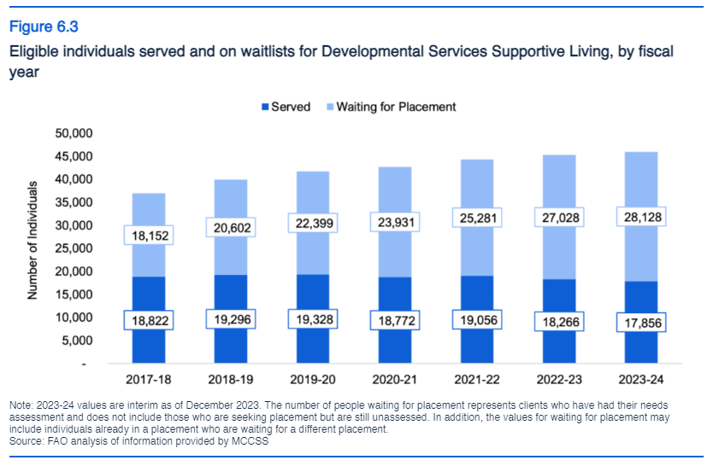
The FAO noted that, in 2018, there were more people accessing supportive housing than waiting for it. Six years later, the number of people accessing that service has actually dropped, while the number waiting is now 60% higher than the number served.

Additionally, there are tens of thousands of people waiting for Community Support Services. These services help people with developmental disabilities contribute to and engage safely in their communities, develop valuable competencies and skills, and get the specialized supports they may need from time to time. In 2020, Ontario’s Auditor General reported that 34,000 people were waiting for such services; among those 34,000 people, 60% were receiving no services at all. According to more recent data, this number reached 42,000 in 2023, growing by a quarter in just three years.

Lastly, Ontario has a unique financial support program for people who qualify for developmental services funding: the Passport program, which provides between $5,500 and $45,000 per year to eligible people, depending on their assessed level of need (with an average allocation of about $11,000 per year). This funding can be used to purchase items from a prescribed list published by the Ministry of Children, Community and Social Services.

According to the FAO, 34,500 people are receiving their full Passport allocation, and 31,000 are receiving less than their full allocation. While the number of people receiving any amount of Passport has grown since the 2018 decision to offer the minimum amount to every eligible person, so has the number who are receiving only the minimum amount:

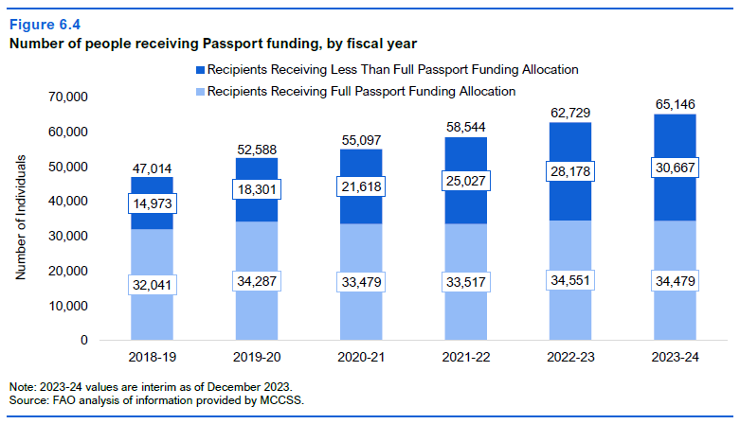

In summary:

- More than 52,000 unique individuals are waiting to access developmental services in Ontario. Many of these 52,000 people are waiting for multiple types of support.
- More than 28,000 people are waiting for housing-related support.
- More than 42,000 people are waiting for community support services, including staff support, caregiver respite, employment services, and mental health services.
- More than 30,000 people are waiting to receive their full Passport allocation.

For further clarification or questions, please contact:
Teresa Kruze. tkruze@rogers.com 416-727-8145

